Name: Poorab Gangwani

Section: 2B1

Enrollment #: CS191092

**LAB # 4**

**Experimental Verification of Voltage & Current Division Rules**

**Lab Objectives:**

* To experimentally verify Voltage division rule.
* To experimentally verify Current division rule.

**Apparatus Required:**

* DC Power Supply
* Digital Multimeter
* Resistors
* Connecting wires
* Bread board

**PRE-LAB:**

**Voltage Division Rule:**

The voltage divisionrule states that for a series combination of **N** resistors supplied by a voltage **V**, the voltage across an individual series connected resistance is given by,

$V_{k}= \left\lfloor \frac{R_{k}}{R_{1}+ R_{2}+R_{3}…..+R_{N}}\right\rfloor V$ eq. 4.1

For example in the circuit shown in Fig. 3.2, the voltage across resistance R1 is given by,

$V_{1}= \left\lfloor \frac{R_{1}}{R_{1}+ R_{2}+R_{3}}\right\rfloor V$ eq. 4.2

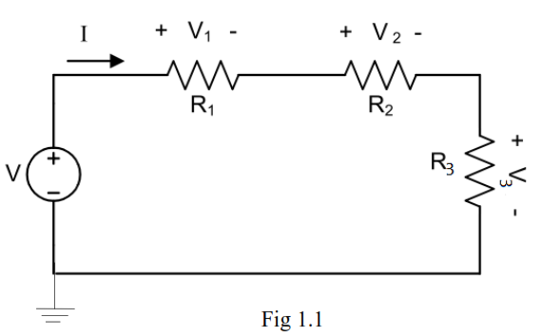

*Fig. 4.1: Series Circuit*



**Current Division Rule:**

The **current division** rule states that for a parallel combination of N resistors being supplied by a total current I, the current flowing through an individual resistor is given by,

$I_{k}= \left\lfloor \frac{\frac{1}{R_{k}}}{{\frac{1}{R}}_{1}+ \frac{1}{R_{2}}+\frac{1}{R_{3}}…..+\frac{1}{R_{N}}}\right\rfloor I$ eq. 4.3

For example in the circuit shown in Fig 3.3, the current through resistor R1 is given by,

$I_{1}= \left\lfloor \frac{\frac{1}{R_{1}}}{{\frac{1}{R}}_{1}+ \frac{1}{R_{2}}}\right\rfloor I$ eq. 4.4

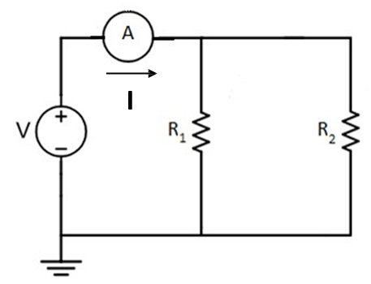

*Fig. 4.2: Parallel Circuit*

**IN-LAB:**

**LAB TASK 1(a): Voltage Division Rule**

1. Develop the circuit shown in Fig 4.1 on a bread board.
2. Set the DC supply voltage to 5V & choose R1 = 1 kΩ R2 = 10 kΩ R3 = 100 kΩ
3. Measure the voltage across each of the resistances in Fig 4.1, using a digital multimeter. Write your results in table 4.1(a)
4. Now theoretically calculate voltage across R1, R2 & R3 using eq. 4.2.

**Calculations:**

V1=R1/R1+R2+R3 x V

V1=0.045

V2=R2/R1+R2+R3 x V

V2=0.45

V3=R3/R1+R2+R3 x V

V3=4.504

*Table 4.1: lab task 1(a)*

|  |
| --- |
| **Measured Voltages across Resistances** |
| **VR1 =0.045V** |
| **VR2 =0.45V** |
| **VR3 =4.504V** |
| **VR1+VR2+VR3 =4.999** |

Q: Is measured voltage and calculated voltage across R3 same?

____________yes________________________________________________________

**LAB TASK 1(b): Voltage Division Rule**

1. Develop the circuit shown in Fig 4.1 on a bread board.
2. Set the DC supply voltage to 5V & choose R1 = 13 kΩ, R2 = 20 kΩ, R3 = 30 kΩ
3. Measure the voltage across each of the resistances in Fig 4.1, using a digital multimeter. Write your results in table 4.1(b)
4. Now theoretically calculate voltage across R1, R2 & R3 using eq. 4.2.

**Calculations:**

V1=13K/63K x 5V

V1=1.03V

V2=20K/63K x 5V

V2=1.58V

V3=30K/63K x 5V

V3=2.38

*Table 4.1: lab task 1(b)*

|  |
| --- |
| **Measured Voltages across Resistances** |
| **VR1 =1.032V** |
| **VR2 =1.587** |
| **VR3 =2.381** |
| **VR1+VR2+VR3 =5V** |

Q: Is measured voltage and calculated voltage across R2 same?

______________________________________yes_______________________________________

**LAB TASK 2(a): Current Division Rule**

1. Develop the circuit shown in Fig.4.2 on a bread board.
2. Set the DC power supply to 5V and choose R1 as 10 kΩ and R2 as 100 kΩ.
3. Measure the total current (I) flowing in the circuit.
4. Measure the current flowing into resistors R1 and R2 and fill table 4.2(a).
5. Now theoretically calculate current flowing into R1, R2 & R3 using eq. 4.4.

**Calculations:**

I1=V/R1

=5/10K

=500UA

I2=V/R2

=5V/100K

=50UA

I=I1 + I2

I=550UA

*Table 4.2: lab task 2(a)*

|  |
| --- |
| **Measured currents** |
| **I =0.000548894** |
| **IR1 =0.000499156** |
| **IR2 =0.000049738** |

Q: Is measured current and calculated current through R2 same?

yes

__________________________________________________________________________

**LAB TASK 2(b): Current Division Rule**

1. Develop the circuit shown in Fig.4.2 on a bread board.
2. Set the DC power supply to 5V and choose R1 as 10 kΩ , R2 as 20 kΩ
3. Measure the total current (I) flowing in the circuit.
4. Measure the current flowing into resistors R1, R2 and R3and fill table 4.2(b).
5. Now theoretically calculate current flowing into R1, R2 & R3 using eq. 4.4.

**Calculations:**

**I1=V/R1**

**=5/10K**

**=0.0005A**

**I2=V/R2**

**=V/R2**

**=5/20K**

**0.00025A**

*Table 4.2: lab task 2(b)*

|  |
| --- |
| **Measured currents** |
| **I = 0.00075A** |
| **IR1 =0.0005A** |
| **IR2 =0.00025A** |
| **IR3 =** |

Q: Is measured current and calculated current through R3 same?

_____________yes_____________________________________________________________

**Conclusion:**

**__________________________________________________________________**

**__________________________________________________________________**

**__________________________________________________________________**

Name: _Poorab gangwani_________________

Enrollment #: __CS191092___________

**POST-LAB ASSIGNMENT # 4**

Q.1) Calculate the voltage drops across the 2kΩ and 3kΩ resistors in the circuit shown.

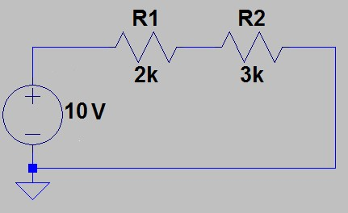

Voltage drop across R1

=2/2+3 x 10 = 4V

Voltage drop across R2

3/2+3 x 10 = 6V

Q.2) Calculate the current flowing through the 10kΩ and 20kΩ resistors in the circuit shown.

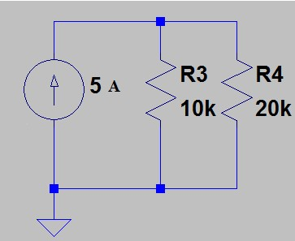

Current Flowing through R3

I1=20k/30k x 5

=3.33

I2=10k/30k x 5

=1.66